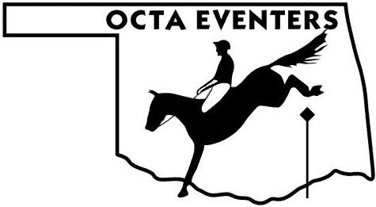
2022 Horse Show Participation Record
For OCTA Members
USEA Recognized Shows (Starter Division only) & Eventing Schooling Shows (out of state)
Name of Member/Rider ____________________________ Senior___ Junior ___
Name of Horse ___________________________________ USEA# _____________
Date of Show | Name of Show - indicate if Schooling (CT or HT) show or USEA Recognized show | Division | # of Riders in Division | Placing
- Please submit this form by December 1st.
- Please use one form per horse/rider combination(Make sure and use the same name for the horse at every show to avoid confusion!).
- It is very important to include the number of riders in the division/class-this determines your points.
- Please include eventing shows in which you participated that are not Oklahoma based schooling shows- combined tests, horse trials, or USEA recognized shows when participating in the STARTER Division.
- In order to receive points-Show results must be figured off scores from a licensed Dressage judge.
- This information will be used to tally 2022 Year End Award Points.
- Suggestion – keep this form with your Coggins for each horse – fill it out throughout the year so show results aren’t missed.
Mail form to: Miranda Hassler, OCTA-Horse Show Record 8800 S. Drexel Ave #2104 Oklahoma City, OK 73159 postmarked by December 1st, 2022 or email to freereinsporthorses@gmail.com.

Name of Member/Rider ____________________________ Senior ___ Junior ___
Name of Horse ___________________________________ USEA# _____________

Date of Show | Name of Show - indicate if Schooling (CT or HT) show or USEA Recognized show | Division | # of Riders in Division | Placing

